CHAPTER ONE

INTRODUCTION

INTRODUCTION
1.1 Background of the Study
The global packaging industry represents one of the most dynamic and technologically advanced sectors of modern manufacturing, with an estimated market value exceeding $1 trillion annually. Within this expansive domain, automated packaging machinery has emerged as a critical enabler of industrial efficiency, product safety, and supply chain optimization. The Vertical Form-Fill-Seal (VFFS) machine, first conceptualized in the mid-20th century, has evolved from simple mechanical devices into sophisticated mechatronic systems capable of achieving production rates exceeding 200 packages per minute while maintaining precise weight tolerances of less than one percent [1].
This graduation project addresses the design, analysis, and development of a VFFS packaging system specifically engineered for the precision dosing of granular and powdered materials, with particular emphasis on sodium chloride (table salt) packaging. Table salt was deliberately selected as the target material due to its unique engineering challenges; its abrasive nature, moisture-dependent bulk density variations, and free-flowing characteristics make it an optimal candidate for rigorous mechatronic system validation and performance benchmarking. The project integrates mechanical engineering principles, bulk solids mechanics, control systems theory, and modern simulation techniques to deliver a comprehensive engineering solution that meets contemporary industrial standards for accuracy, reliability, and hygienic compliance.
1.1.1 Evolution of Packaging Automation
The historical trajectory of packaging automation reflects broader patterns of industrial development, from the mechanization of the 19th century through the digital revolution of the late 20th and early 21st centuries. Early packaging operations were entirely manual, relying on human labor for filling, sealing, and labeling operations. The introduction of semi-automatic filling machines in the 1930s marked the first significant departure from manual methods, though these early devices offered limited throughput and minimal process control [2].
The post-World War II era witnessed accelerated development in packaging machinery, driven by rising consumer demand and the expansion of mass retail distribution. The invention of the form-fill-seal concept by Walter Zwoyer in the 1930s, later refined and commercialized by companies such as Hayssen and Bosch, established the fundamental operating principles that continue to govern modern VFFS systems. These early machines employed mechanical cams, gears, and linkages to coordinate the sequential operations of film transport, forming, filling, and sealing [3].
The digital revolution of the 1980s and 1990s transformed VFFS technology through the integration of programmable logic controllers (PLCs), servo motor drives, and electronic sensors. This transition from purely mechanical to electromechanical systems enabled unprecedented levels of precision, flexibility, and diagnostic capability. Contemporary VFFS machines incorporate advanced motion control algorithms, real-time process monitoring, and network connectivity, establishing the foundation for Industry 4.0 integration [4].
1.1.2 Role of VFFS Systems in Global Supply Chains
Vertical Form-Fill-Seal machines occupy a strategically significant position within global food and consumer goods supply chains. Their compact footprint, high operational speed, and adaptability to diverse product specifications make them the preferred packaging solution for granular and powdered commodities including food products, pharmaceuticals, chemicals, and agricultural materials. Industry estimates indicate that VFFS systems account for approximately 35% of all flexible packaging operations worldwide [5].
The economic significance of VFFS technology extends beyond direct equipment sales to encompass substantial operational savings through reduced labor requirements, minimized material waste, and enhanced product protection. Modern VFFS systems achieve material utilization rates exceeding 95% through precise film tracking and optimized bag forming geometry, contributing to both economic efficiency and environmental sustainability objectives [6].
Furthermore, the hygienic design principles incorporated into contemporary VFFS machinery address increasingly stringent food safety regulations, including FDA requirements in the United States and EU hygiene standards in Europe. Stainless steel construction, smooth surface finishes, and clean-in-place (CIP) capabilities ensure compliance with Good Manufacturing Practice (GMP) guidelines essential for food-grade packaging operations [7].
1.1.3 Precision Dosing: The Critical Role of Auger Fillers
Among the various dosing mechanisms employed in VFFS applications, auger filling systems represent the most widely adopted technology for granular and powdered materials. The auger filler operates on the principle of positive displacement, wherein a rotating helical screw (auger) within a cylindrical housing transports material from a supply hopper to a discharge point. The volumetric displacement per revolution is determined by the auger geometry, enabling precise control of dispensed quantity through accurate angular positioning [8].
The fundamental relationship governing auger filling performance derives from the geometric displacement of the helical screw:
$$V_{th} = (π/4) × (D² - D_s²) × P$$
Where $V_{th}$ represents the theoretical volumetric displacement per revolution, D is the outer diameter of the auger flight, D_s is the shaft diameter, and P is the pitch of the helical flight. This geometric relationship, first systematically analyzed by Roberts and Rademacher in the context of screw conveyor theory, provides the theoretical foundation for auger design and performance prediction [9].
However, the practical implementation of auger filling involves significant deviations from ideal theoretical behavior due to the complex mechanical properties of bulk solids. Factors including particle size distribution, bulk density variation, interparticle friction, cohesive forces, and wall friction effects all contribute to the difference between theoretical and actual volumetric efficiency. Empirical studies indicate that typical volumetric efficiency factors range from 0.4 to 0.9, depending on material properties and operating conditions [10].
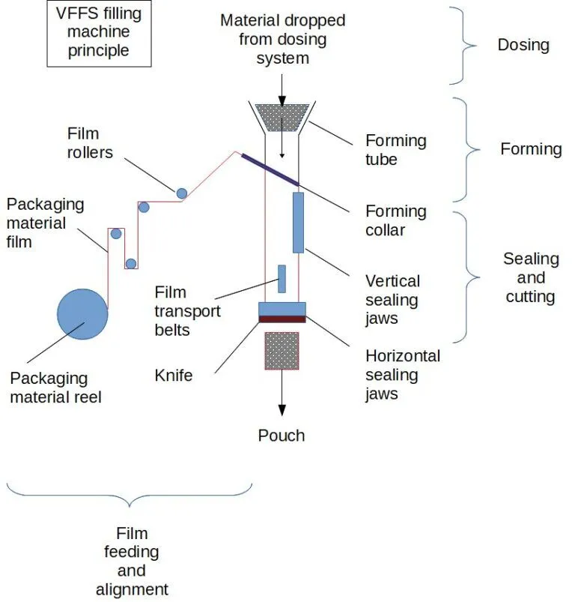
Figure 1.1: Schematic illustration of VFFS machine with integrated auger filling system, showing key functional components including film transport, forming collar, filling zone, and sealing jaws.
1.2 Problem Statement
Despite the widespread adoption of VFFS technology in industrial packaging applications, several persistent challenges limit the achievement of optimal performance in powder and granular material handling. These challenges span mechanical design, process control, and operational reliability domains, creating opportunities for significant engineering improvement through systematic research and development.

1.2.1 Inaccuracy and Inconsistency in Powder Filling
The primary performance metric for any filling system is dosing accuracy, typically expressed as the percentage deviation between target and actual dispensed mass. For commercial packaging operations, regulatory standards such as OIML R87 specify maximum permissible errors based on package weight, with stricter tolerances applied to smaller packages. For a 500g package of salt, the maximum permissible error is typically ±1.5%, corresponding to ±7.5g [11].
Achieving consistent accuracy in auger filling is complicated by several factors inherent to bulk solid behavior. Bulk density variation, resulting from changes in material consolidation, moisture content, or particle packing arrangement, directly affects the mass-to-volume conversion that underlies volumetric dosing principles. Studies have demonstrated that bulk density of granular salt can vary by ±5-10% under normal operating conditions, creating corresponding variations in dispensed mass unless compensated through control system intervention [12].
Additional sources of dosing error include:
• Slip between material and auger flight surfaces, reducing effective displacement;
• Backflow through radial clearance between flight tip and housing wall;
• Incomplete filling of auger flights due to hopper flow irregularities;
• In-flight material continuing to fall after motor stop command;
• Kinematic inertia causing continued rotation during deceleration phases.
The cumulative effect of these error sources can result in total dosing errors exceeding acceptable limits unless addressed through integrated mechanical and control system design.

1.2.2 Structural and Thermal Challenges in Continuous Operation
Industrial VFFS machines are typically required to operate continuously for extended periods, often exceeding eight hours per shift under demanding production schedules. This operational intensity imposes significant mechanical and thermal loads on critical components, particularly the auger drive system and sealing mechanisms.
The auger shaft experiences substantial torsional loading during operation, particularly during startup when breakaway torque is required to initiate motion of compacted material. Analytical calculations for the proposed design indicate maximum torque requirements of approximately 20 N·m under worst-case conditions. The shaft must withstand these loads without excessive deflection that would compromise the critical radial clearance between rotating and stationary components [13].
Thermal considerations arise from multiple sources including motor heating, friction at bearing surfaces, and heat transfer from the sealing jaws. The sealing operation for plastic films typically requires temperatures of 150-200°C, creating thermal gradients that can affect component dimensions and material properties. Thermal expansion of the auger shaft, if not properly accommodated, can result in binding or increased friction within the dosing chamber [14].

1.2.3 Limitations of Conventional Empirical Design Methods
Traditional approaches to auger filler design have relied heavily on empirical correlations and industry rules of thumb developed through decades of practical experience. While these methods have proven effective for conventional applications, they exhibit significant limitations when applied to novel materials, non-standard operating conditions, or precision requirements exceeding typical industrial norms.
The Conveyor Equipment Manufacturers Association (CEMA) provides standardized design equations for screw conveyors, but these formulations were developed for bulk material transport rather than precision dosing applications. The translation from continuous conveying to discrete volumetric metering introduces additional complexity not fully addressed by conventional design methodologies [15].
Furthermore, empirical design approaches provide limited insight into the underlying physical phenomena governing system behavior. Without fundamental understanding of powder flow mechanics, stress distribution, and dynamic response, optimization of design parameters becomes a trial-and-error process rather than a systematic engineering exercise. This project addresses this gap through the integration of analytical modeling, numerical simulation, and experimental validation methodologies.
1.2.4 Control System Latency and Electromechanical Synchronization
Beyond mechanical and thermal constraints, a critical challenge in VFFS operations lies in the mechatronic synchronization between the dispensing mechanism and the sealing actuation. Traditional systems often suffer from control latency and sensor feedback delays, leading to the 'dribble effect'—where residual powder falls into the seal area during jaw closure, compromising package integrity. Achieving precise, real-time coordination requires an advanced control architecture capable of microsecond-level execution. This necessitates the transition from conventional empirical timing to highly responsive, microcontroller-driven motion profiling to seamlessly synchronize servo-actuated dosing with the kinematic cycle of the packaging process.

1.3 Aim and Objectives
The overarching aim of this graduation project is to design, analyze, and validate a complete VFFS packaging system with integrated auger filler specifically optimized for the precision packaging of granular sodium chloride. The project encompasses mechanical design, control system development, and comprehensive performance validation through analytical and numerical methods.
The specific objectives of the project are:
- To develop a comprehensive understanding of bulk solids mechanics and powder flow behavior as applied to auger filling systems, including the characterization of material properties affecting dosing accuracy.
- To design the mechanical architecture of a VFFS auger filling system, including auger geometry, drive train specification, hopper configuration, and flow control mechanisms, meeting industrial standards for hygiene and reliability.
- To establish analytical models for volumetric displacement, torque requirements, and structural loading, enabling quantitative prediction of system performance.
- To perform multiphysics numerical simulations including static structural analysis, thermal analysis, and modal analysis to validate mechanical design decisions and identify potential failure modes.
- To develop control system architecture incorporating servo motor positioning, sensor integration, and feedback algorithms to achieve target dosing accuracy of ±1.5% for 500g packages.
- To correlate analytical predictions with numerical simulation results, establishing confidence in the design methodology and identifying areas requiring refinement.

1.4 Research Questions
This project addresses the following research questions that guide the investigation and provide focus for the engineering analysis:
RQ1.What auger geometry (outer diameter, shaft diameter, pitch, and flight profile) optimizes the trade-off between volumetric displacement capacity and mechanical stress distribution for the target 500g dose requirement?
RQ2.How do bulk density variations and powder flow properties affect dosing accuracy, and what control strategies can compensate for these variations in real-time operation?
RQ3.What are the critical structural loading conditions for the auger shaft and drive train, and what safety factors ensure reliable operation under worst-case scenarios including material caking and startup conditions?
RQ4.How does thermal expansion from sealing jaw heating affect component clearances and dosing accuracy, and what design measures mitigate thermal effects?
RQ5.What is the correlation between analytical predictions and numerical simulation results, and how do deviations inform design refinement decisions?

1.5 Scope and Limitations
The scope of this graduation project encompasses the complete engineering design and analysis of a VFFS auger filling system, with specific boundaries defining the extent of investigation and areas explicitly excluded from consideration.
1.5.1 Scope of Work
The project scope includes:
- Mechanical design of auger screw, central shaft, spinner plate, and associated tooling;
- Specification and selection of servo motor, gearbox, and drive train components;
- Design of hopper and agitator system for consistent material feeding;
- Development of a centralized mechatronic control architecture utilizing advanced microcontrollers (ESP32) for precise servo motion profiling, real-time synchronization, PID-based thermal control of sealing jaws, and comprehensive sensor data fusion;
- Analytical modeling of volumetric displacement, torque, and power requirements;
- Finite Element Analysis (FEA) of structural, thermal, and modal behavior;
- Validation of design through correlation between analytical and numerical results.

1.5.2 Limitations
The following aspects are explicitly outside the scope of this project:
• Physical prototype fabrication and experimental testing (the project is limited to design and simulation phases);
• Economic analysis, cost estimation, and market feasibility studies;
• Investigation of alternative dosing technologies (cup fillers, weigh fillers, etc.);
• Long-term reliability testing and wear analysis under extended operation.
The target material is limited to granular sodium chloride (table salt) with specified particle size distribution and moisture content. While the design principles may be applicable to other granular materials, validation is specifically performed for salt packaging applications.

1.6 Significance of the Study
This graduation project contributes to engineering knowledge and industrial practice through multiple pathways of significance:
1.6.1 Academic Contribution
The project demonstrates the integration of multiple engineering disciplines—mechanical design, bulk solids mechanics, control systems, and numerical simulation—within a unified design framework. The systematic correlation between analytical models and finite element analysis provides a methodology applicable to similar mechatronic system development. Furthermore, the detailed treatment of powder flow phenomena augments the existing literature on auger filling technology, which has historically received less scholarly attention than other bulk material handling systems [16].
1.6.2 Industrial Relevance
The design outcomes directly address industrial requirements for high-speed, accurate, and reliable powder packaging. The target specifications—500g packages at 20 bags per minute with ±1.5% accuracy—represent typical production requirements for medium-scale food packaging operations. The methodology employed, combining theoretical analysis with simulation validation, offers a template for systematic design optimization that can reduce development time and prototyping costs [17].
1.6.3 Technological Innovation
The integration of advanced servo control with mechanical flow control mechanisms (spinner plate) represents an innovative approach to addressing the persistent challenge of dribble elimination in free-flowing granular materials. The dual-core ESP32 control architecture with distributed processing of motion control and thermal management tasks demonstrates the application of modern embedded systems technology to packaging machinery [18].

1.7 Methodology Overview
The project follows a systematic engineering design methodology progressing from requirements definition through conceptual design, detailed analysis, and validation. The overall approach integrates analytical modeling, computational simulation, and design verification in an iterative framework.

1.7.1 Research Design Framework
The methodology adopts a mixed-methods approach combining theoretical analysis, numerical simulation, and design validation. The research design follows the classical engineering method: problem definition, background research, conceptual design, detailed analysis, and verification. This structured approach ensures comprehensive coverage of all technical aspects while maintaining traceability from requirements to final design [19].

1.7.2 Mechatronic System Design Phase
Following the conceptualization, the detailed physical and electronic architecture is developed. This phase encompasses:
- Mechanical CAD Modeling: Generating detailed 3D models of the auger, hopper, drive train, and support structures using parametric CAD software (e.g., SOLIDWORKS) to ensure spatial integration and manufacturability;
- Electrical & Control Architecture: Selecting the appropriate sensors, actuators (servo motors), and microcontroller units (e.g., ESP32), accompanied by developing the wiring schematics and preliminary control logic flowcharts for the dispensing and sealing synchronization.

1.7.3 Analytical Modeling Phase
The analytical phase establishes mathematical models governing system behavior:
• Volumetric displacement theory based on auger geometry and powder properties;
• Torque and power requirements derived from material resistance and inertial loading;
• Structural mechanics equations for stress, deflection, and critical speed analysis;
• Control system models for motion profiling and feedback compensation.

1.7.4 Numerical Simulation Phase
Finite Element Analysis (FEA) using SOLIDWORKS Simulation and ANSYS Mechanical provides detailed insight into:
- Static structural response under maximum torque loading;
- Thermal distribution and expansion effects;
- Modal characteristics and resonance avoidance;
- Motion dynamics and interference validation.

1.7.5 Validation and Correlation
The final phase correlates analytical predictions with simulation results, quantifying deviations and establishing confidence bounds for design decisions. Statistical comparison of key performance parameters—stress, deflection, torque, and dosing accuracy—validates the analytical framework and confirms design adequacy.
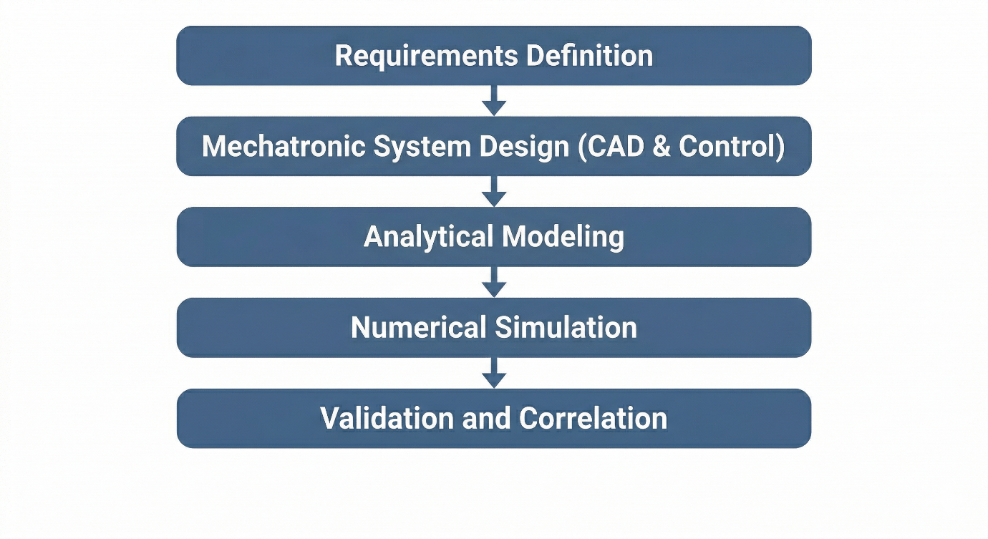
Figure 1.2: Project methodology flowchart showing the sequential phases from requirements definition through mechatronic system design (CAD and Control), analytical modeling, numerical simulation, and final validation.
1.8 Organization of the Report
This graduation project report is organized into seven chapters, each addressing specific aspects of the design and analysis process:
Chapter One: Introduction presents the background, problem statement, objectives, research questions, scope, and significance of the study. This chapter establishes the context and motivation for the project.
Chapter Two: Literature Review provides a comprehensive survey of existing knowledge in VFFS technology, powder rheology, auger engineering, and multiphysics simulation. This chapter identifies the theoretical foundations and research gaps addressed by the project.
Chapter Three: System Design and Specifications details the design requirements, conceptual development, and final mechanical architecture. CAD representations and control system logic are presented in this chapter.
Chapter Four: Analytical Modeling and Calculations presents the mathematical foundations, kinematic and kinetic models, torque and power estimation, and structural mechanics equations governing system behavior.
Chapter Five: Multiphysics Simulation and Validation describes the computational setup, static structural analysis, thermal-structural coupling, modal analysis, and correlation between analytical and simulation results.
Chapter Six: Results Discussion and Evaluation synthesizes the findings, evaluates machine performance, discusses mechatronic synergy, and assesses the contribution to engineering knowledge.
Chapter Seven: Conclusion and Future Work summarizes the key findings, evaluates objective fulfillment, provides recommendations for prototype fabrication, and suggests directions for future research including AI/ML integration.

The report also includes comprehensive appendices containing engineering drawings, control documentation, simulation reports, and detailed calculation spreadsheets.

